NATIONAL CHEMISTRY OLYMPIAD 2026

ASSIGNMENTS PRELIMINARY ROUND 2
To be held between 16th and 23rd March 2026

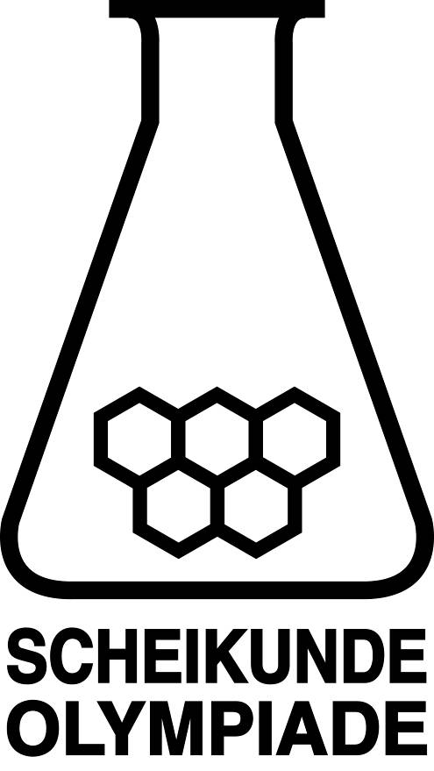



▪ This preliminary round consists of 20 multiple choices questions divided over 8 topics, and 3 problems with a total of 13 open questions, in addition to an answer sheet for the multiple choice questions.
▪ Use the answer sheet to answer the multiple choice questions.
▪ For the open questions, use a separate answer sheet for each of the three problems. Remember to include your name on each sheet.
▪ The maximum score for this paper is 94 points.
▪ The preliminary round lasts three hours in total.
▪ Required materials: (graphic) calculator and BINAS 7th edition or ScienceData 1st edition or BINAS 5th edition, English version. “Green chemistry” table is included.
▪ The total number of points available for each question is stated.
▪ Unless otherwise stated, standard conditions apply: T = 298 K and p = p₀.

This test was made possible with the support of the following people:
Olav Altenburg
Kees Beers
Imre Bekkering
Alex Blokhuis
Johan Broens
Guus Bukkems
Jacob van Hengst
Dick Hennink
Marijn Jonker
Emiel de Kleijn
Jasper Landman
Bob Lefeber
Evert Limburg
Marte van der Linden
Han Mertens
Anna Reinhold
Joran de Ridder
Geert Schulpen
Nena Slaats

The final editing was done by:
Martin Groeneveld, Piet Mellema and Pia Scheffer

The test was translated into English by:
Lilian Buuron
Eline Knol
Riëtte Pienaar
Jan Rombach
Lauren Rutherford

- Multiple choice questions total 40 points
For each question, write your answer (letter) on the answer sheet. The answer sheet can be found at the end of this examination booklet.
Marks: 2 points for each correct answer.
 |  | Carbon chemistry
1 |  | How many stereoisomers does the following compound have?  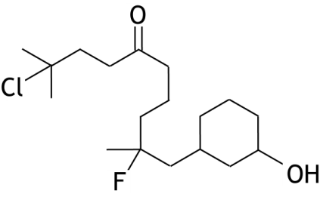
 | A | 2
 | B | 3
 | C | 4
 | D | 8
 | E | 16
2 |  | Polylactic acid is a polymer formed from lactic acid.  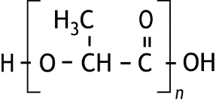  Polylactic acid can be drawn as follows:  The ester bonds in polylactic acid can be broken through a reaction with water under acidic conditions.  What is the minimum amount of H₂O, in mmol, which must react in order to break all of the ester linkages in 500 mg polylactic acid with n = 12?
 | A | 6.23
 | B | 6.36
 | C | 6.80
 | D | 6.94

 |  | Reaction rate and equilibrium
3 |  | Cyanide (CN—) can be converted to cyanate (OCN—) using hypoiodite (IO—) in an alkaline solution:  CN— + IO— → OCN— + I—  This conversion occurs according to the following mechanism:  IO— + H₂O HIO + OH— fast  CN— + HIO ICN + OH— fast  ICN + OH— → HOCN + I— slow  HOCN + OH— → OCN— + H₂O fast  What is the rate equation?
 | A
 | B
 | C
 | D
 | E
4 |  | The reaction rate of the conversion of iodide to iodine by hydrogen peroxide in hydrochloric acid is studied by allowing the following reaction to take place:  H₂O₂(aq) + 2 I—(aq) + 2 H⁺(aq) → I₂(aq) + 2 H₂O(l)  The initial rate rate₀ of this reaction is measured in different experiments.  The following data was obtained using solutions prepared with the volumes of the various solutions shown below.  The rate equation is given as rate = k [H₂O₂]ª[I—]^{b}[H⁺]^{c}.  What are the values of a, b and c?  a b c
  experiment | H₂O₂ solution (mL) | KI solution  (mL) | hydrochloric acid (mL) | water  (mL) | rate₀  (mol L^{—1} s^{—1})
  1 | 2.0 | 2.0 | 2.0 | 4.0 | 1.00·10^{—4}
  2 | 2.0 | 2.0 | 4.0 | 2.0 | 1.02·10^{—4}
  3 | 2.0 | 4.0 | 2.0 | 2.0 | 2.05·10^{—4}
  4 | 4.0 | 2.0 | 2.0 | 2.0 | 2.07·10^{—4}
 | A | 0 1 0
 | B | 0 1 1
 | C | 1 1 0
 | D | 1 1 1
 | E | 1 2 0
 | F | 1 2 1
5 |  | The reaction rate at 100 °C for a certain reaction is four times faster than the reaction rate at 50 °C, measured with the same initial concentrations.  What is the activation energy of this reaction?
 | A | 1.52·10³ J mol⁻¹
 | B | 1.21·10⁴ J mol⁻¹
 | C | 2.78·10⁴ J mol⁻¹
 | D | 5.40·10⁴ J mol⁻¹
 | E | 8.01·10⁴ J mol⁻¹
6 |  | The following reaction equation is given:  SO₂(g) + NO₂(g) SO₃(g) + NO(g) K_{p} = 3.75  All four gases are added together in a reaction vessel and each gas has an initial partial pressure of 0.60 bar.  What is the partial pressure of SO₂(g) when equilibrium has been reached?
 | A | 0.19 bar
 | B | 0.25 bar
 | C | 0.35 bar
 | D | 0.41 bar
 |  | Structures and formulas
7 |  | How many electrons with quantum number m_{l} = 1 are present in an As atom in its ground state?
 | A | 5
 | B | 7
 | C | 15
 | D | 18
8 |  | How many π bonds and how many σ bonds are present in a molecule of succinic acid, as shown below?  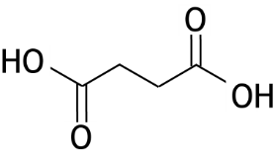
 |  | number of π bonds | number of σ bonds
 | A | 2 | 5
 | B | 2 | 7
 | C | 2 | 9
 | D | 2 | 13
 | E | 4 | 5
 | F | 4 | 7
 | G | 4 | 9
 | H | 4 | 13

9 |  | Gold has a density of 19.3·10³ kg m⁻³. The unit cell of gold’s crystal lattice is a cube with edges of 4.08·10⁻¹⁰ m.  How many atoms are present in the unit cell of gold, and in which of the following types of unit cell is gold crystallised: simple cubic (cubic-P), body-centred cubic (bcc) or face-centred cubic (fcc)?  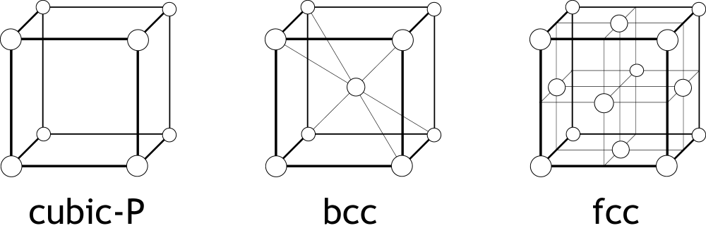
 |  | number of atoms | type of unit cell
 | A | 1 | cubic-P
 | B | 8 | cubic-P
 | C | 2 | bcc
 | D | 4 | bcc
 | E | 4 | fcc
 | F | 8 | fcc
 |  | pH / acid-base
10 |  | A solution of allylamine, C₃H₅NH₂, has a pH of 11.12.  In this solution 3.61% of the allylamine is converted to its conjugate acid.  What is the pK_{a} of the conjugate acid of allylamine?
 | A | 1.44
 | B | 3.77
 | C | 4.31
 | D | 9.69
 | E | 10.23
 | F | 12.56

11 |  | A solution of formic acid, HCOOH, is titrated with a 0.1000 M sodium hydroxide solution.  The change in pH during titration is shown below.  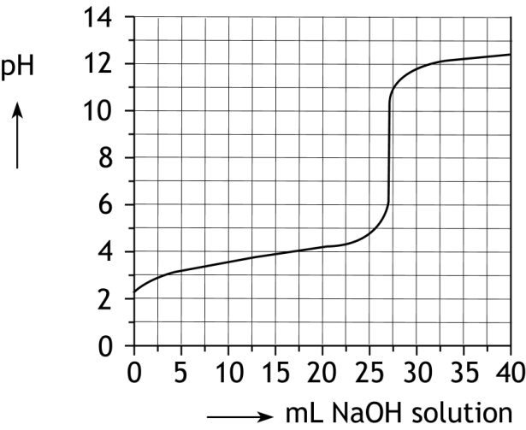  What are the relative concentrations of HCOOH, HCOO— and Na⁺ when 15.0 ml of the 0.1000 M sodium hydroxide solution is added?
 | A | [HCOO—] = [Na⁺] > [HCOOH]
 | B | [HCOO—] > [HCOOH] = [Na⁺]
 | C | [HCOOH] = [Na⁺] > [HCOO—]
 | D | [HCOOH] > [HCOO—] = [Na⁺]
 |  | Redox and electrochemistry
12 |  | The standard electrode potential of the half-equation below is +1.51 V.  MnO₄—(aq) + 8 H⁺(aq) + 5 e— → Mn²⁺(aq) + 4 H₂O(l)  What is the value of the electrode potential of the half-reaction above at 298 K and [MnO₄—] = 0.0100 M, [H⁺] = 0.200 M and [Mn²⁺] = 0.0200 M?
 | A | +1.16 V
 | B | +1.44 V
 | C | +1.50 V
 | D | +1.58 V

13 |  | When charging a lead-acid battery, the following reaction occurs:  2 PbSO₄(s) + 2 H₂O(l) → Pb(s) + PbO₂(s) + 4 H⁺(aq) + 2 SO₄^{2—}(aq)  Below are two statements about the lead-acid battery:  I During charging, PbO₂(s) is formed at the negative electrode.  II During charging, the same amount of SO₄^{2—}(aq) is produced at both electrodes.  Which of the above statements is/are correct?
 | A | neither
 | B | only I
 | C | only II
 | D | both
14 |  | Bronze statues turn slightly green over time. Copper, one of the metals in the bronze alloy, reacts in various ways with oxygen, water, sulfur trioxide, and carbon dioxide, among others, to form copper compounds with various colours. Four of these reactions are shown below.  Reaction 1: 4 Cu + O₂ → 2 Cu₂O  Reaction 2: 2 Cu₂O + O₂ → 4 CuO  Reaction 3: 4 CuO + SO₃ + 3 H₂O → Cu₄SO₄(OH)₆  Reaction 4: 2 CuO + CO₂ + H₂O → Cu₂CO₃(OH)₂  Reaction 1 is a redox reaction.  Which of the other reactions is a / are redox reaction(s)?
 | A | none of them
 | B | only reaction 2
 | C | only reaction 3
 | D | only reaction 4
 | E | reactions 2 and 3
 | F | reactions 2 and 4
 | G | reactions 3 and 4
 | H | all reactions

 |  | Analysis
15 |  | Two IR spectra are shown below.  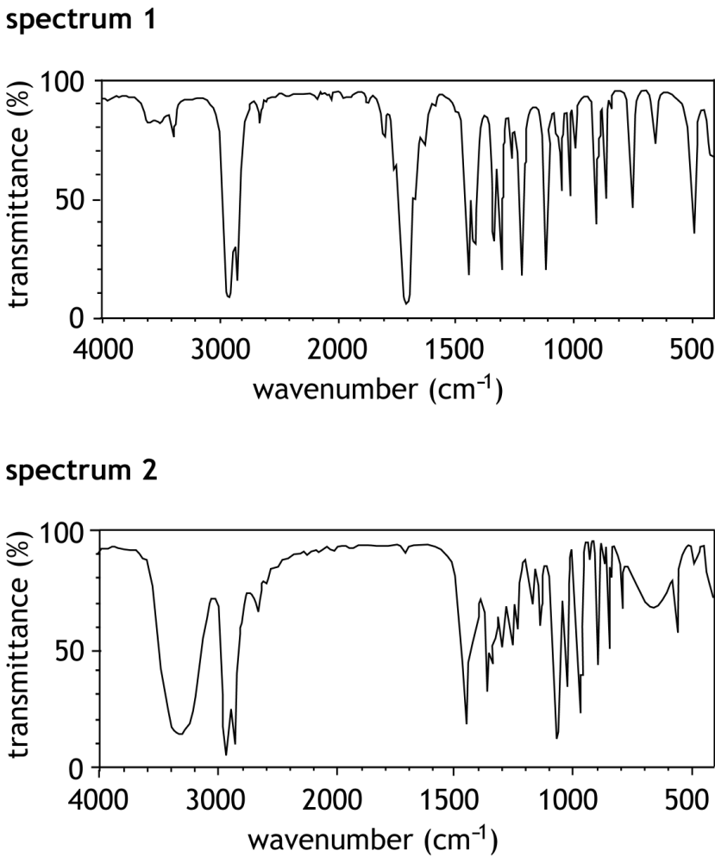  Each spectrum corresponds to one of the substances below.  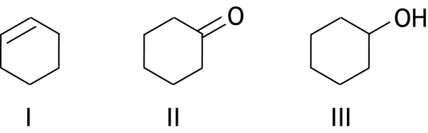  Which spectrum corresponds to which substance?
 |  | spectrum 1 | spectrum 2
 | A | I | II
 | B | I | III
 | C | II | I
 | D | II | III
 | E | III | I
 | F | III | II

 |  | Calculations
16 |  | A white, crystalline solid contains only the atoms C, H, N, and O. Complete combustion of 1.000 g of this substance produces 1.831 g of CO₂ and  0.750 g of H₂O.  Which of the molecular formulas below could this substance have?
 | A | C₃H₆NO₂
 | B | C₄H₄NO₂
 | C | C₆H₁₂N₂O₂
 | D | C₈H₈N₂O₄
17 |  | A gas mixture of 10.0 dm³ consists of methane (CH₄) and propane (C₃H₈). For the complete combustion of this gas mixture, 38.0 dm³ of oxygen gas is required.  What is the volume percentage of propane in the original gas mixture?
 | A | 30.0%
 | B | 40.0%
 | C | 50.0%
 | D | 60.0%
 | E | 70.0%
 |  | Thermochemistry
18 |  | For the reaction:  PCl₃(g) + Cl₂(g) PCl₅(g)  the following applies at 450 K:  What is the value of the equilibrium constant K_{p} of the above equilibrium reaction at 450 K?
   | Δ_{f}H⁰ (J mol^{—1}) | S⁰ (J mol^{—1} K^{—1})
  Cl₂(g) | 0 | 223.1
  PCl₃(g) | —2.870·10⁵ | 311.8
  PCl₅(g) | —3.749·10⁵ | 364.4
 | A | 19.8
 | B | 2.02·10⁴
 | C | 3.17·10⁶
 | D | 1.60·10¹⁰

19 |  | Standard reaction enthalpies of three reactions are given below.  3 C(s) + 4 H₂(g) + 0.5 O₂(g) → C₃H₈O(l) Δ_{r}H⁰₁ = ‒3.18·10⁵ J mol⁻¹  C(s) + O₂(g) → CO₂(g) Δ_{r}H⁰₂ = ‒3.94·10⁵ J mol⁻¹  H₂(g) + 0.5 O₂(g) → H₂O(l) Δ_{r}H⁰₃ = ‒2.86·10⁵ J mol⁻¹  What is the standard enthalpy of reaction for the combustion reaction shown below?  C₃H₈O(l) + 4.5 O₂(g) → 3 CO₂(g) + 4 H₂O(l)
 | A | ‒ 3.62·10⁵ J mol⁻¹
 | B | ‒ 9.98·10⁵ J mol⁻¹
 | C | ‒ 20.08·10⁵ J mol⁻¹
 | D | ‒ 21.16·10⁵ J mol⁻¹
 | E | ‒ 40.16·10⁵ J mol⁻¹
20 |  | For a particular reaction, ∆H⁰ = —3.83·10⁴ J mol—¹ and ∆S⁰ = —113 J mol—¹ K^{—1}. For this question, assume that ∆H⁰ and ∆S⁰ are independent of temperature.  Which of the following statements is correct?
 | A | The reaction occurs at all temperatures.
 | B | The reaction only occurs at temperatures below 66 ºC.
 | C | The reaction only occurs at temperatures above 66 ºC.
 | D | The reaction does not occur at any temperature.

Open questions total 54 points
- Carboxylic acid (16 points)
Carboxylic acids are produced industrially on a large scale, for example for the synthesis of amino acids.
To synthesize alanine, a certain carboxylic acid reacts with Br₂ and then with NH₃ according to the synthesis scheme below:
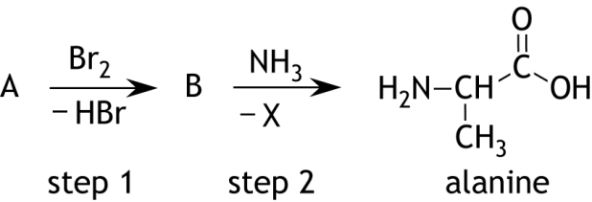
- Complete the following assignments:
- Draw the structural formulas of A and B.
- Give the molecular formula of X.
- Give the name of the type of reaction that occurs in step 2 of the synthesis scheme above. Choose from: addition reaction, elimination reaction, and substitution reaction.
- Besides alanine, another amino acid is also formed. Draw the structural formula
of this other amino acid. 5
E280 is a preservative whose main component is a carboxylic acid with the molecular formula C₂H₅COOH. Use of a preservative requires high purity. The C₂H₅COOH content in a sample of E280 can be determined by iodometric titration.
200 mg of a sample of E280 is transferred to a conical flask and dissolved in water. Excess iodide ions and excess iodate ions are added to the solution. The equation for the reaction that occurs is:
6 C₂H₅COOH + IO₃— + 5 I— → 6 C₂H₅COO— + 3 I₂ + 3 H₂O reaction 1
- Write the equation for the half-reaction for conversion of IO₃— to I₂ . In this
half-reaction, include only the particles IO₃—, I₂, C₂H₅COOH, C₂H₅COO—, H₂O and e—. 4
35.0 mL of 0.100 M sodium thiosulfate solution is then added to the solution.
The equation for the reaction that occurs is:
I₂ + 2 S₂O₃^{2—} → 2 I— + S₄O₆^{2—} reaction 2
The resulting mixture is titrated with a 0.0500 mL solution of I₂. 9.75 mL of this
I₂ solution was needed to react with the remaining thiosulfate.
- Calculate the mass percentage of C₂H₅COOH in the examined sample E280. 7

- A promising home battery (12 points)
To make the energy transition a success, affordable rechargeable home batteries are needed. Li-ion batteries are currently used for this purpose. To avoid being solely dependent on lithium, alternatives are actively being researched. A promising alternative is the Mg-ion home battery. A schematic diagram of the Mg-ion home battery is shown below.
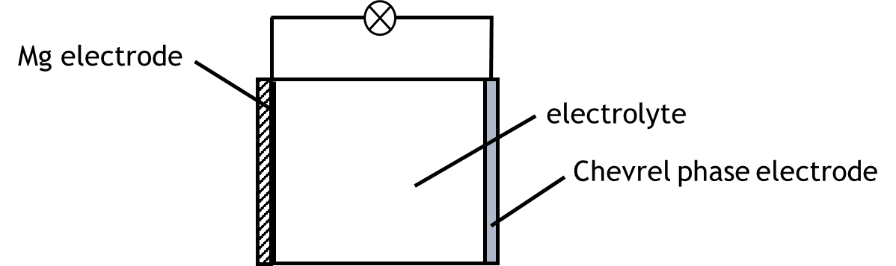
During discharge of the Mg-ion home battery the following reactions occur:
Mg → Mg²⁺ + 2 e— E⁰ = —2.37 V
Mo₆S₈ + 2 Mg²⁺ + 4 e— → Mg₂Mo₆S₈ E⁰ = —1.30 V
- Calculate the Gibbs energy for the formation of Mg₂Mo₆S₈ in the Mg-ion home battery, under standard conditions. Use ΔG⁰ = — nFΔE⁰ . Give your answer in J mol^{—1} Mg₂Mo₆S₈. 3
The Chevrel phase electrode consists of a stack of Mo₆S₈ units. These units contain voids. The Mg²⁺ ions generated at the Mg electrode during discharging migrate to the Chevrel phase electrode and are absorbed into these voids.
The resulting Mg₂Mo₆S₈ units consist of a Mo₆¹²⁺ cluster surrounded by eight S^{2—} ions and two Mg²⁺ ions contained in the voids. The Mo₆¹²⁺ cluster can be viewed as an octahedron of 6 Mo²⁺ ions. This Mo₆¹²⁺ cluster contains 24 4d-electrons.
In a positively charged Mo₆ cluster, each Mo ion can be connected to four other
Mo ions through covalent bonds. These covalent bonds are formed by the 4d-electrons from the Mo ions. These covalent bonds stabilize a positively charged Mo₆ cluster.
- Based on the information above, explain in which substance the positively charged
Mo₆ cluster is more stable: in Mg₂Mo₆S₈ or in Mo₆S₈. 4
The thickness of the Mg electrode for a fully charged Mg-ion home battery is 10.0 μm. The thickness of the Mg electrode varies during use of the Mg-ion home battery, and the Mg electrode is thinnest after a complete discharge of the Mg-ion home battery.
- Calculate the thickness (in μm) of the Mg electrode after complete discharge of
the Mg-ion home battery. Assume that:
- the Chevrel phase electrode consisting of 2.5 g Mo₆S₈ has completely reacted;
- both electrodes have a surface area of 100 cm²;
- the Mg has reacted evenly over the electrode surface. 5

- Synthesis and function of methyl red (26 points)
Methyl red is a substance used as an indicator in acid-base and redox titrations. The structural formula of methyl red is shown below.
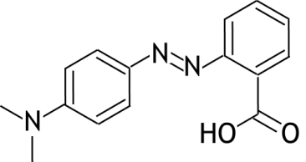
- Explain whether optical isomers and/or cis-trans isomers of methyl red can exist. 3
Methyl red can be produced through two reactions. In the first reaction, the amino group of anthranilic acid (substance 1) is converted to a diazonium group using sodium nitrite solution and hydrochloric acid via a process called diazotization. The incomplete equation for this reaction is shown below.
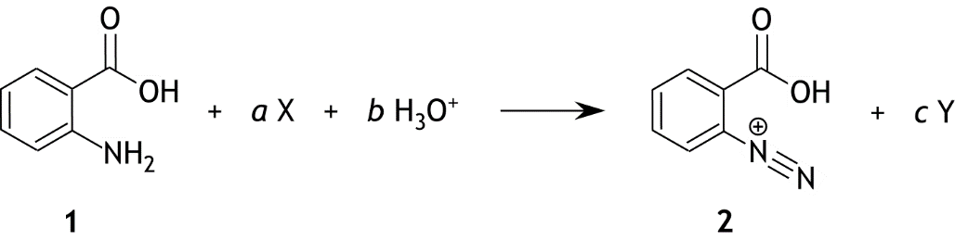
- Give the formula for substance X and substance Y and the coefficients a , b and c to obtain
a balanced equation for the reaction. 3
The mechanism of this reaction consists of several steps. In one of these steps, intermediate 3, shown below, is formed.
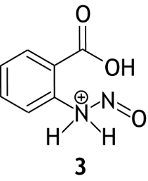
Reactant 1 is converted to intermediate 3 by a reaction with a positively charged ion.
- Draw the Lewis structure of the charged ion that reacts with reactant 1. In this
Lewis structure, place the formal charge in the correct place. 3

The mechanism of the conversion of intermediate 3 to ion 2 is described step-by-step below.
Step 1: A bonding pair of electrons between the O atom and the N atom in intermediate 3 binds an H atom from the adjacent N atom. A double bond between the N atoms is created through bond rearrangement.
Step 2: A proton is transferred from the N atom to a water molecule.
Step 3: One of the non-bonding electron pairs on the O atom of the OH group created in step 1 binds a proton from an H₃O⁺ ion.
Step 4: By displacement of bonding and non-bonding electron pairs, H₂O leaves the molecule and ion 2 is formed.
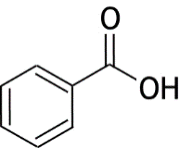
- Represent steps 1 to 4 of the mechanism using structural formulas. Use the information
below.
— Use the notation R for the side group: .
— Draw all bonding and non-bonding electron pairs.
— Indicate with curly arrows ( ) how electron pairs move.
— Place all formal charges in the correct place. 8
In a second reaction, a diazonium coupling occurs between ion 2 and
N,N-dimethylaniline according to the incomplete reaction equation below.
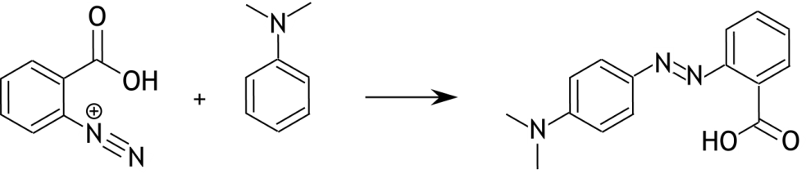
In this incomplete reaction equation, one particle is missing.
- Give the formula for the missing particle in the incomplete reaction equation above and
indicate whether it should be placed before or after the arrow. 1
This reaction can occur because N,N-dimethylaniline has resonance structures where positions with a 1— charge exist in the benzene ring. This delocalization also involves the N atom. One of these resonance structures results in the formation of a methyl red molecule.
- Draw this resonance structure. Give your answer as Lewis structure including all formal charges in the correct place. 2

Methyl red is a weak acid. When methyl red is added to a colourless solution, the resulting colour depends on the pH of the solution. The following equilibrium plays a role:
mrH + H₂O H₃O⁺ + mr—
where mr— is the conjugate base of methyl red (mrH). The pK_{a} of methyl red is 5.00.
At high pH, mr— absorbs maximum light at a wavelength of 429 nm, and at low pH, mrH absorbs maximum light at a wavelength of 520 nm. By measuring the absorbance at 429 nm (A₄₂₉) and at 520 nm (A₅₂₀), the concentrations of mrH and mr— can be determined using the Lambert-Beer law. From this, the pH of the solution can then be calculated.
The table below gives the molar extinction coefficients of mrH and mr— at two wavelengths.
 | ε_{429 nm}  (L mol^{—1} cm^{—1}) | ε_{520 nm}  (L mol^{—1} cm^{—1})
mr— | 1.25·10⁴ | 1.33·10³
mrH | 3.86·10³ | 2.15·10⁴
A small amount of methyl red was added to a colourless solution and the following absorbances were measured: A₄₂₉ = 0.108 and A₅₂₀ = 0.219.
A cuvette with a path length of 1.00 cm was used for the measurements.
- Calculate the pH of the solution. 6

Green Chemistry

The twelve principles of green chemistry are:

1. Prevention. Preventing waste is better than treating or cleaning up waste after it is created.
2. Atom economy. Synthetic methods should try to maximize the incorporation of all materials used in the process into the final product. This means that less waste will be generated as a result.
3. Less hazardous chemical syntheses. Synthetic methods should avoid using or generating substances toxic to humans and/or the environment.
4. Designing safer chemicals. Chemical products should be designed to achieve their desired function while being as non-toxic as possible.
5. Safer solvents and auxiliaries. Auxiliary substances should be avoided wherever possible, and as non-hazardous as possible when they must be used.
6. Design for energy efficiency. Energy requirements should be minimized, and processes should be conducted at ambient temperature and pressure whenever possible.
7. Use of renewable feedstocks. Whenever it is practical to do so, renewable feedstocks or raw materials are preferable to non-renewable ones.
8. Reduce derivatives. Unnecessary generation of derivatives — such as the use of protecting groups — should be minimized or avoided if possible; such steps require additional reagents and may generate additional waste.
9. Catalysis. Catalytic reagents that can be used in small quantities to repeat a reaction are superior to stoichiometric reagents (ones that are consumed in a reaction).
10. Design for degradation. Chemical products should be designed so that they do not pollute the environment; when their function is complete, they should break down into non-harmful products.
11. Real-time analysis for pollution prevention. Analytical methodologies need to be further developed to permit real-time, in-process monitoring and control before hazardous substances form .
12. Inherently safer chemistry for accident prevention. Whenever possible, the substances in a process, and the forms of those substances, should be chosen to minimize risks such as explosions, fires, and accidental releases.

atom economy
percentage yield
E -factor

47th National Chemistry Olympiad 2026 preliminary round 2
Answer sheet: multiple choice questions

no. | answer  (letter) | (score)
1
2
3
4
5
6
7
8
9
10
11
12
13
14
15
16
17
18
19
20
 | Total

Name:

Teacher:

School:

